MAIN PAGE
FIBRE CEMENT SIDING & SOFFIT
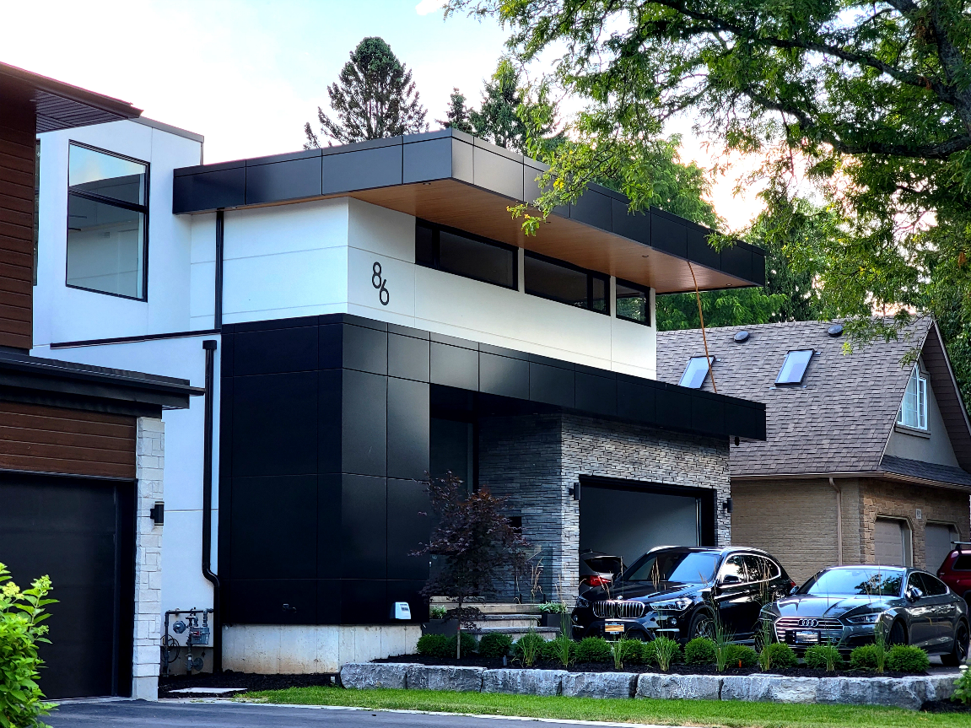
Industrial / Residential / Commercial / Multy-Family / Custom Homes / Hospitality
What Are Fiber Cement Panels?
Fiber cement siding—also known as fiber cement cladding—is a composite material made of cement reinforced with cellulose fibers (replacing asbestos since the 1980s). It's widely used for both residential and commercial exteriors. ...... (Learn More / Expand)
Advantages:
- Durable & low maintenance: Resistant to rot, warping, and pests like termites.
- Fire-resistant: Non-combustible, used in high fire-risk areas.
- Weather-resistant: Engineered to withstand climate extremes, including storms, moisture, and temperature fluctuations.
- Install-friendly: Panels come in sizes that minimize waste and simplify installation, although cutting requires care due to silica dust risks.
- Available in a variety of colors, textures, and profiles, vinyl siding allows for versatile design options to match any architectural style. Its lightweight construction ensures quick and easy installation, providing a high-performance, long-lasting solution for both renovations and new builds.

“Fiber Cement Siding: Design Without Limits, Engineered for Every Climate”
When it comes to fiber cement siding, two industry leaders stand out for their unique strengths: Nichiha, known for “Design Without Limits,” pushes architectural creativity forward with bold textures, rainscreen technology, and finishes that transform both residential and commercial projects into modern statements. On the other hand, James Hardie, trusted worldwide and “Engineered for Every Climate,” delivers unmatched durability and beauty, combining advanced ColorPlus finishes, climate-specific engineering, and strong warranties to ensure performance and curb appeal for decades. Together, they showcase how fiber cement siding can merge style, innovation, and long-term value.

Nichiha Product Overview (EXPANDED)
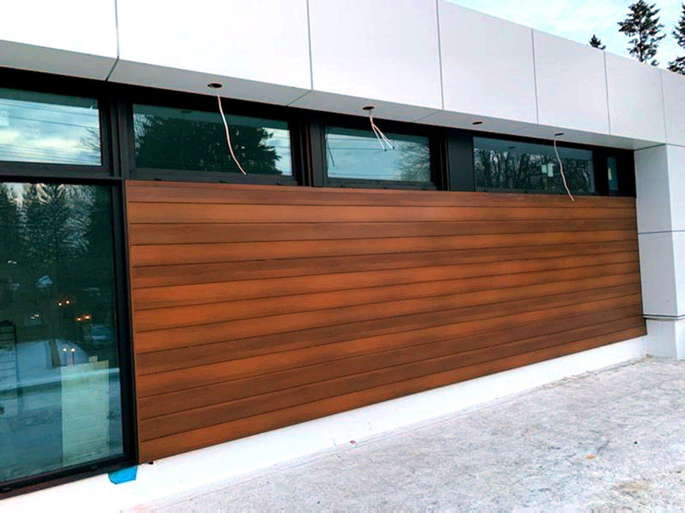
Expanded … Where Innovation Meets Aesthetics
Nichiha combines cutting-edge building technology with design versatility, delivering fiber cement panels that balance durability, ease of installation, and bold visual appeal. Their products are known for bringing architectural creativity to life without sacrificing performance.

Applications
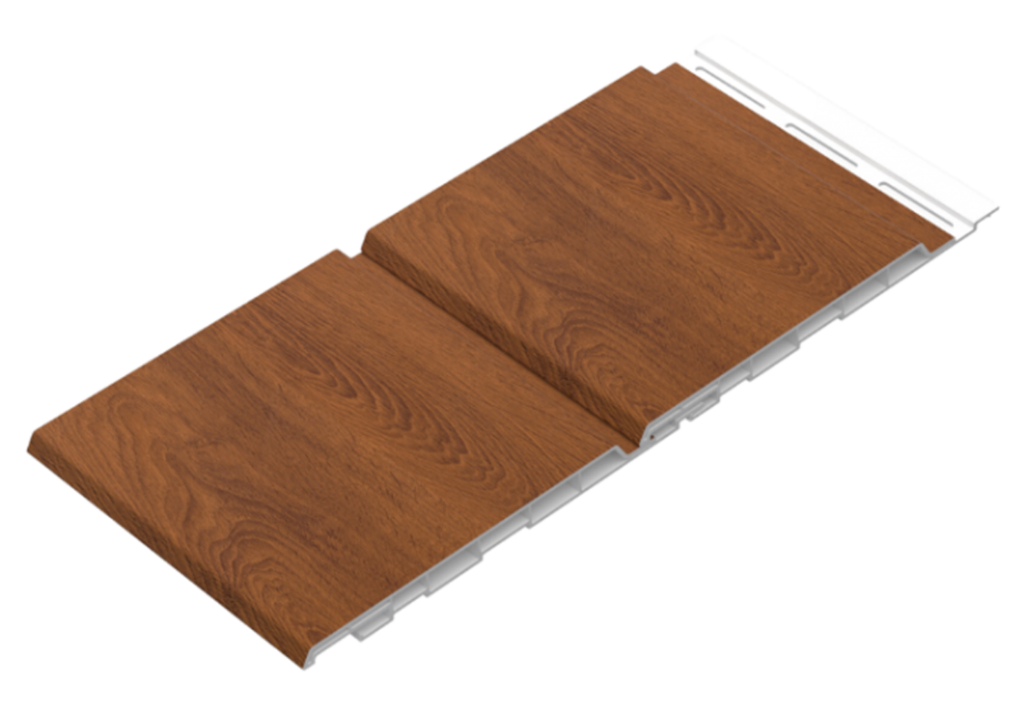

Nichiha’s panels are designed to adapt to nearly any project type. They are used extensively in commercial buildings, residential homes, multi-family developments, custom homes, hospitality venues, interiors, and modular construction. Whether it’s a sleek urban façade or a warm interior accent wall, Nichiha panels offer the flexibility to suit diverse design needs.
In addition, Nichiha’s systems feature built-in rainscreen technology, which creates a ventilated cavity behind the panels to manage moisture, improve air circulation, and extend the life of the building envelope.

Technology & Performance
Nichiha integrates smart installation systems to reduce labor and minimize errors. Their Ultimate Clip & Starter Track system ensures panels align securely and quickly, while integrated rainscreen assemblies protect the structure by channeling water away from the substrate.

Product Choices:

6” Dual-Panel
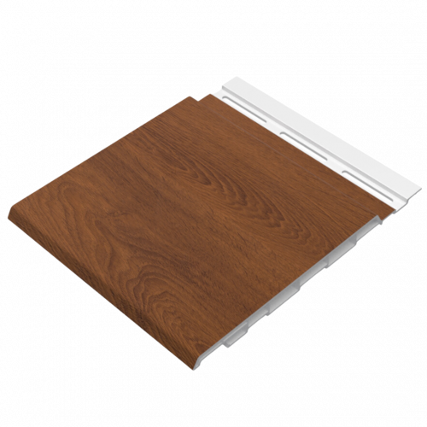

Material: Recycled Rigid PVC
Available Lengths: Solid - 12 ft, 16 ft, 20 ft and 30’, Custom Lengths Available
Profile Dimensions: 6” wide × 0.5” thick
Installation Options: Horizontal and Vertical
Sizes:
- AWP (Architectural Wall Panels) in sizes 1818 (455 mm × 1818 mm) and 3030 (455 mm × 3030 mm)
- Thickness options: 16 mm, 18 mm, 21 mm depending on panel series
Textures & Finishes:
- Styles include wood, stucco, smooth, concrete, stone, brick, corrugated, block, high-gloss, semi-gloss, and matte
- Specialty lines:
  - Miraia: high-gloss reflective finish for modern styling, horizontal panels (17 7/8″ × 71 9/16″; 16 mm thick)
  - Ribbed (Dimension Series): textured with recessed reveals; available in horizontal or vertical orientation (455 mm × 3030 mm; 16 mm thick)
  - TuffBlock: rugged, textured finish—a modern alternative to stucco
  - Illumination Series: sleek satin finish with a wide color palette for sophisticated design
Accessories & Installation:
- Tongue-and-groove edges (with sealing strip for weather-resistance) on EX Series panels
- Matching external corners, trim, sealants, and touch-up paint kits
- NichiTrim line in smooth or cedar textures, in a variety of board widths (2½″ to 11¼″), with 10-ft lengths and ¾″ to 1″ thickness—great for trim applications

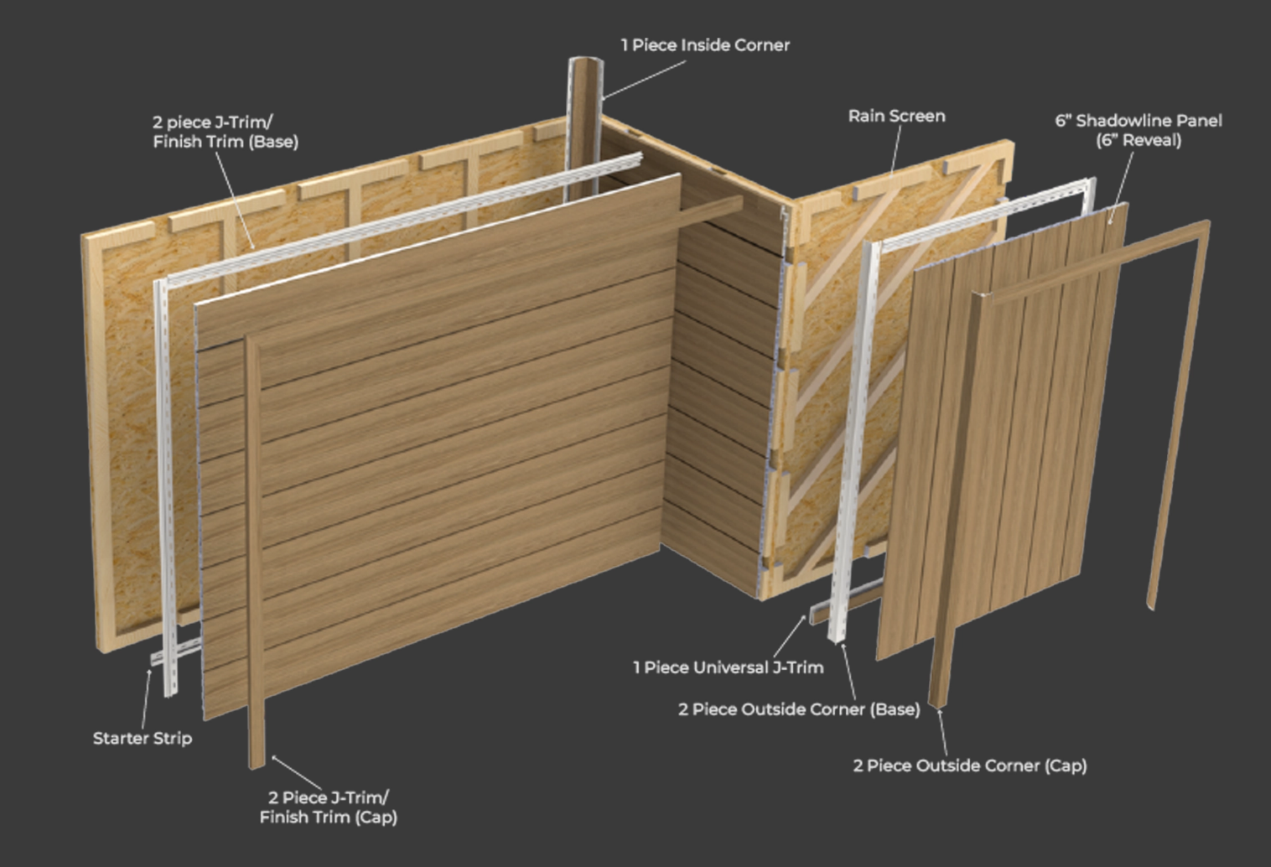

Trims
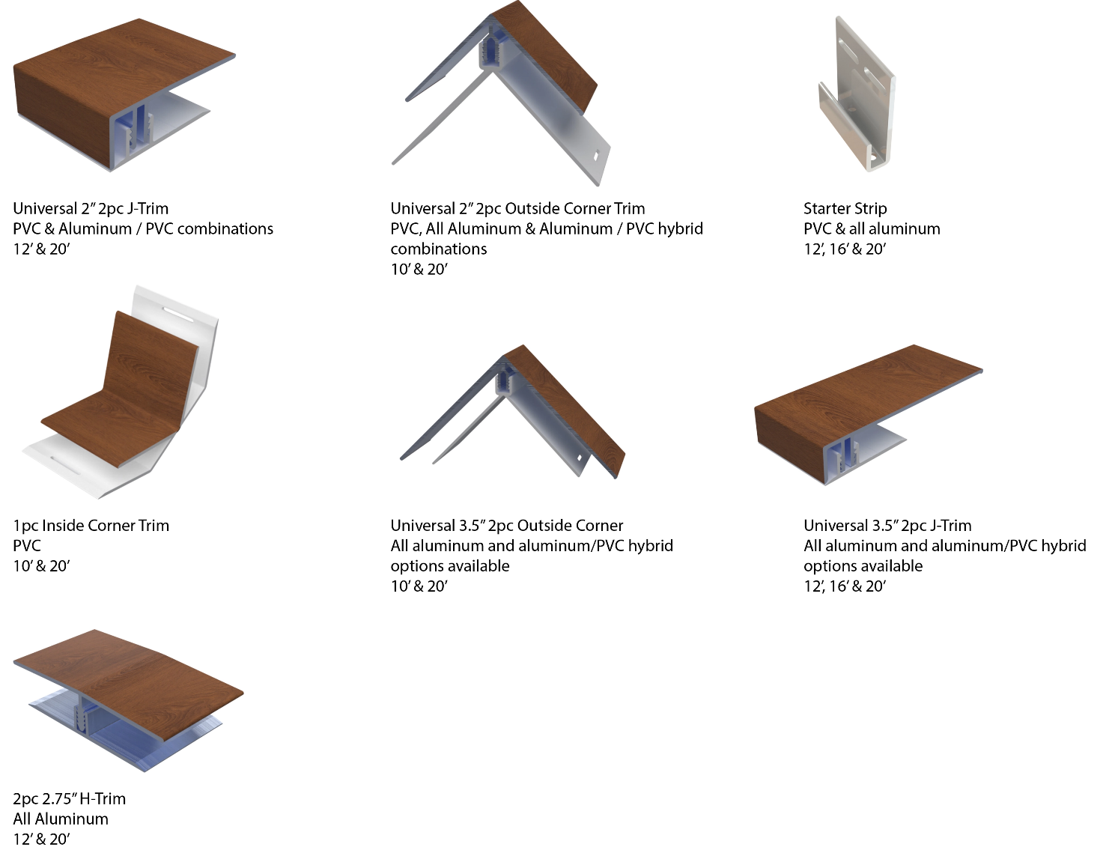

Stunning Finishes That Look and Feel Real
Authentic Textures. Lasting Performance. Designed to Impress.
Our extensive lineup includes rich woodgrains, sleek anodized looks, bold solid tones, metallic sheens, and elegant interior-specific finishes—each developed to meet a wide range of design needs.
Crafted using advanced film technology, many of our finishes feature a high-performance polyvinylidene fluoride (PVDF) top layer. This ensures long-term durability, superior UV resistance, and exceptional colour stability in all environments.
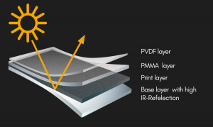
What sets these finishes apart:
- Heat-reflective technology for cooler surfaces and longer lifespan
- Embossed textures that simulate the natural feel of wood and other materials
- High pattern variation to avoid repetition and create a more organic look
- Matte and textured options for modern, high-end aesthetics

Whether you’re designing a modern exterior or an elegant interior feature, CladCan delivers finishes that look as good as they perform.

Looking for something specific?
Get in touch for our full catalogue of available finishes and custom options.

Woodgrain Finishes
6” Dual-Panel

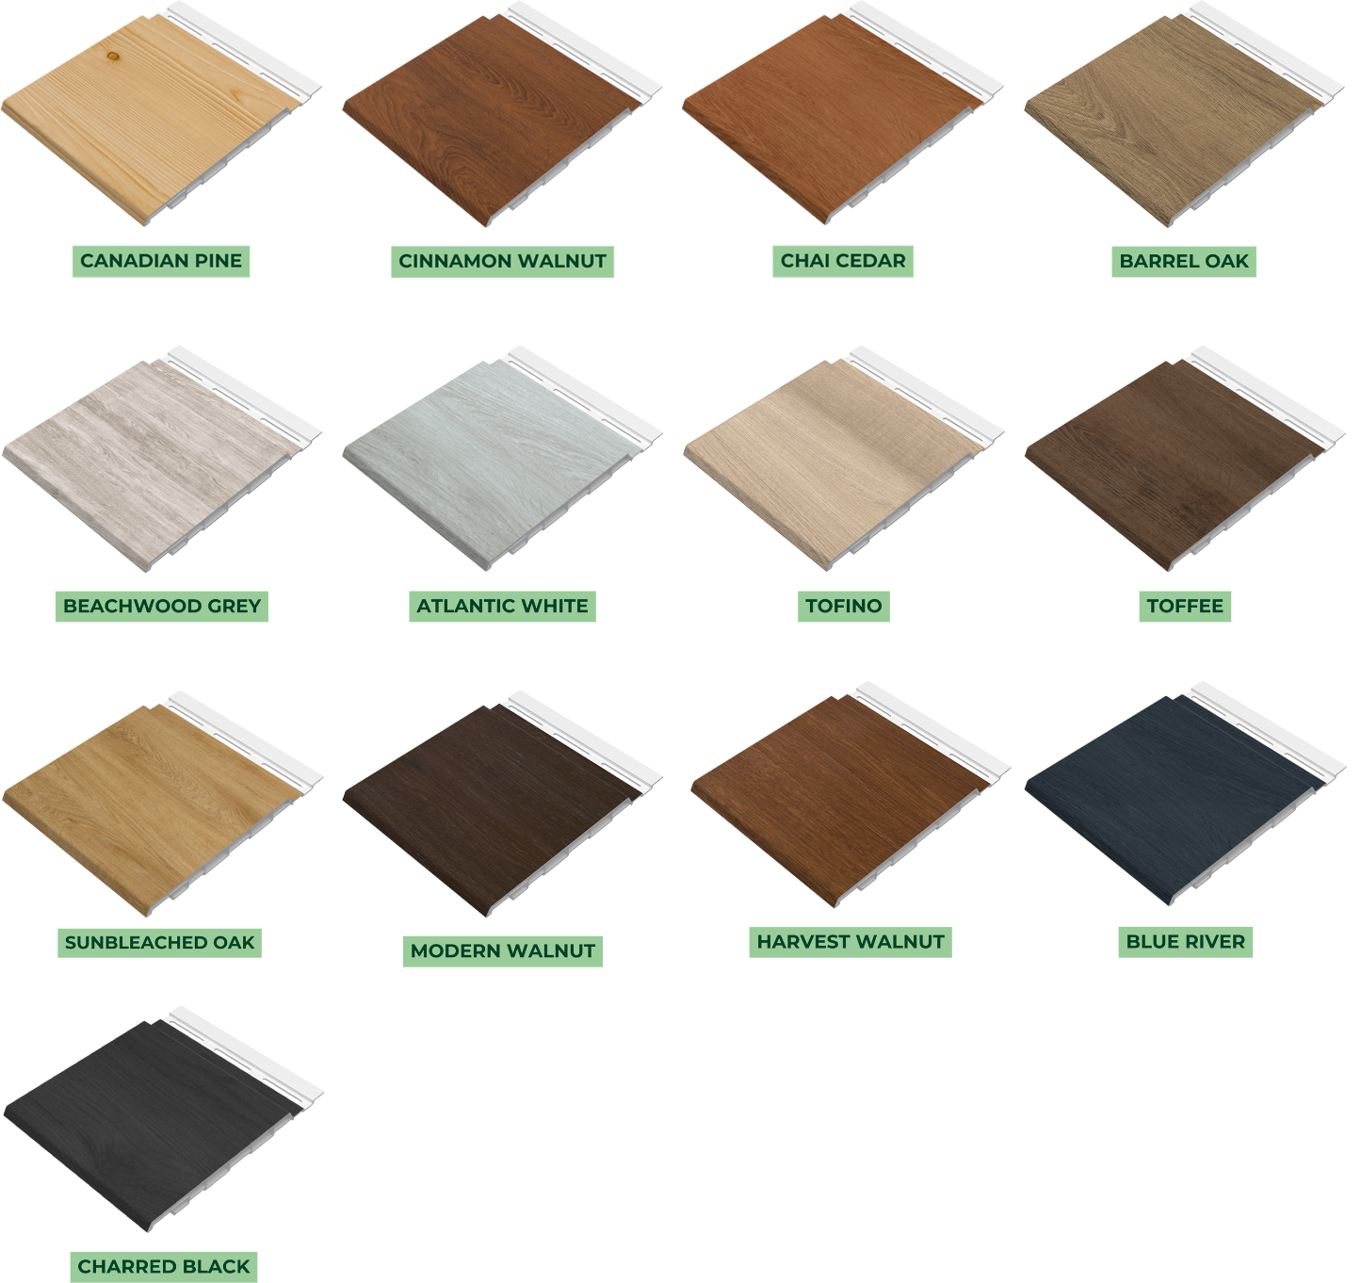

Solid Finishes
6” Dual-Panel

